# 8th Testing – 24th May

Story 17: Sort Files – By Meta Data

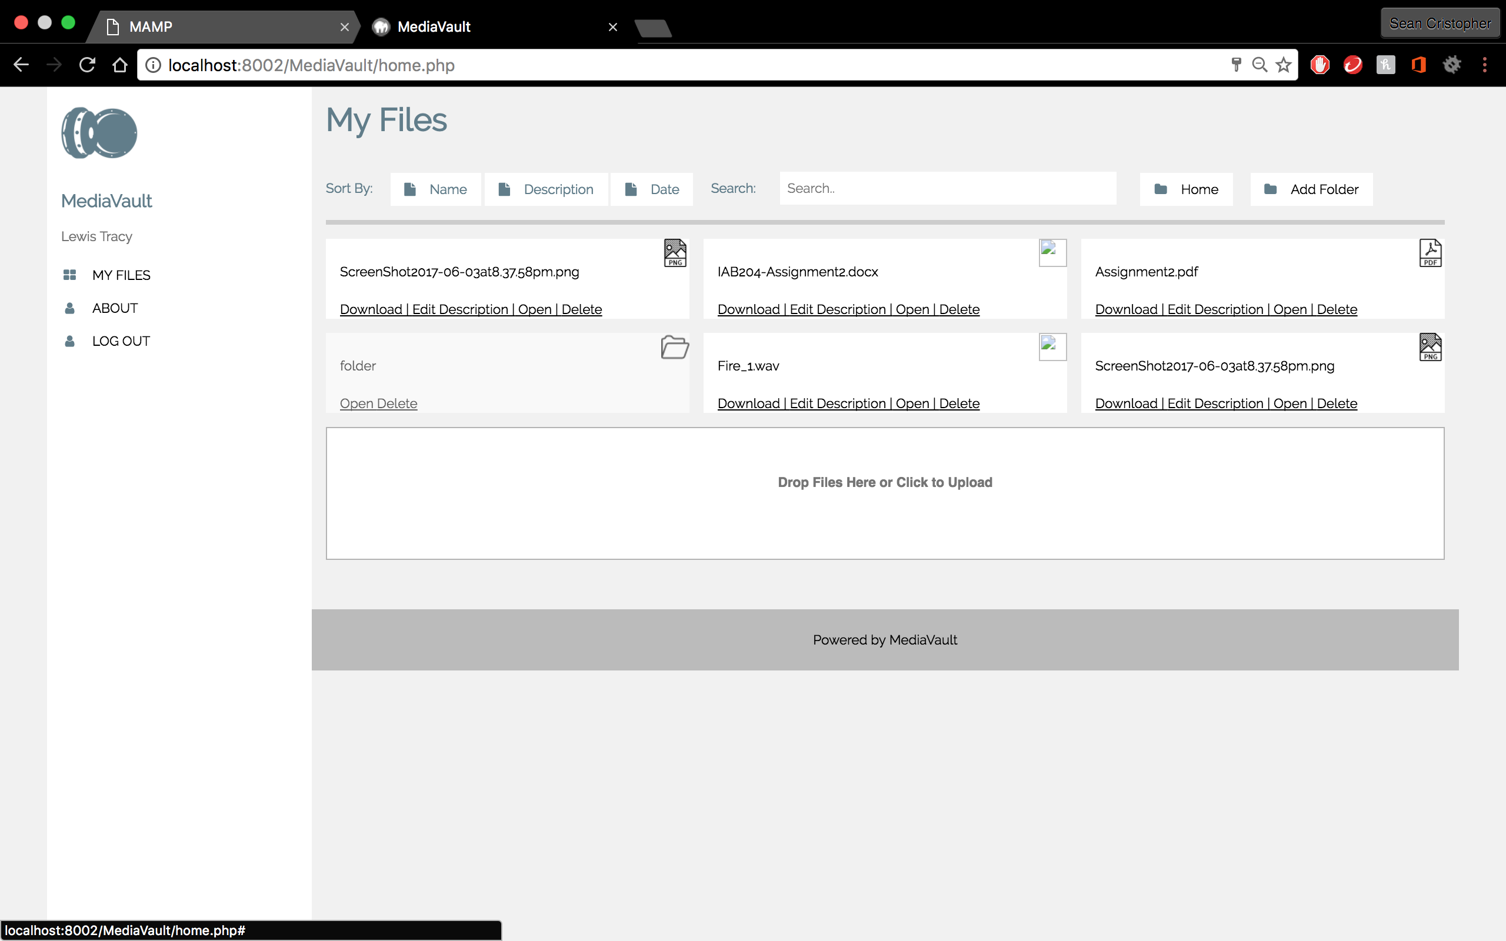

* Tests shows that sort files by meta data doesn’t functions

Story 17B: Sort Files – By Name

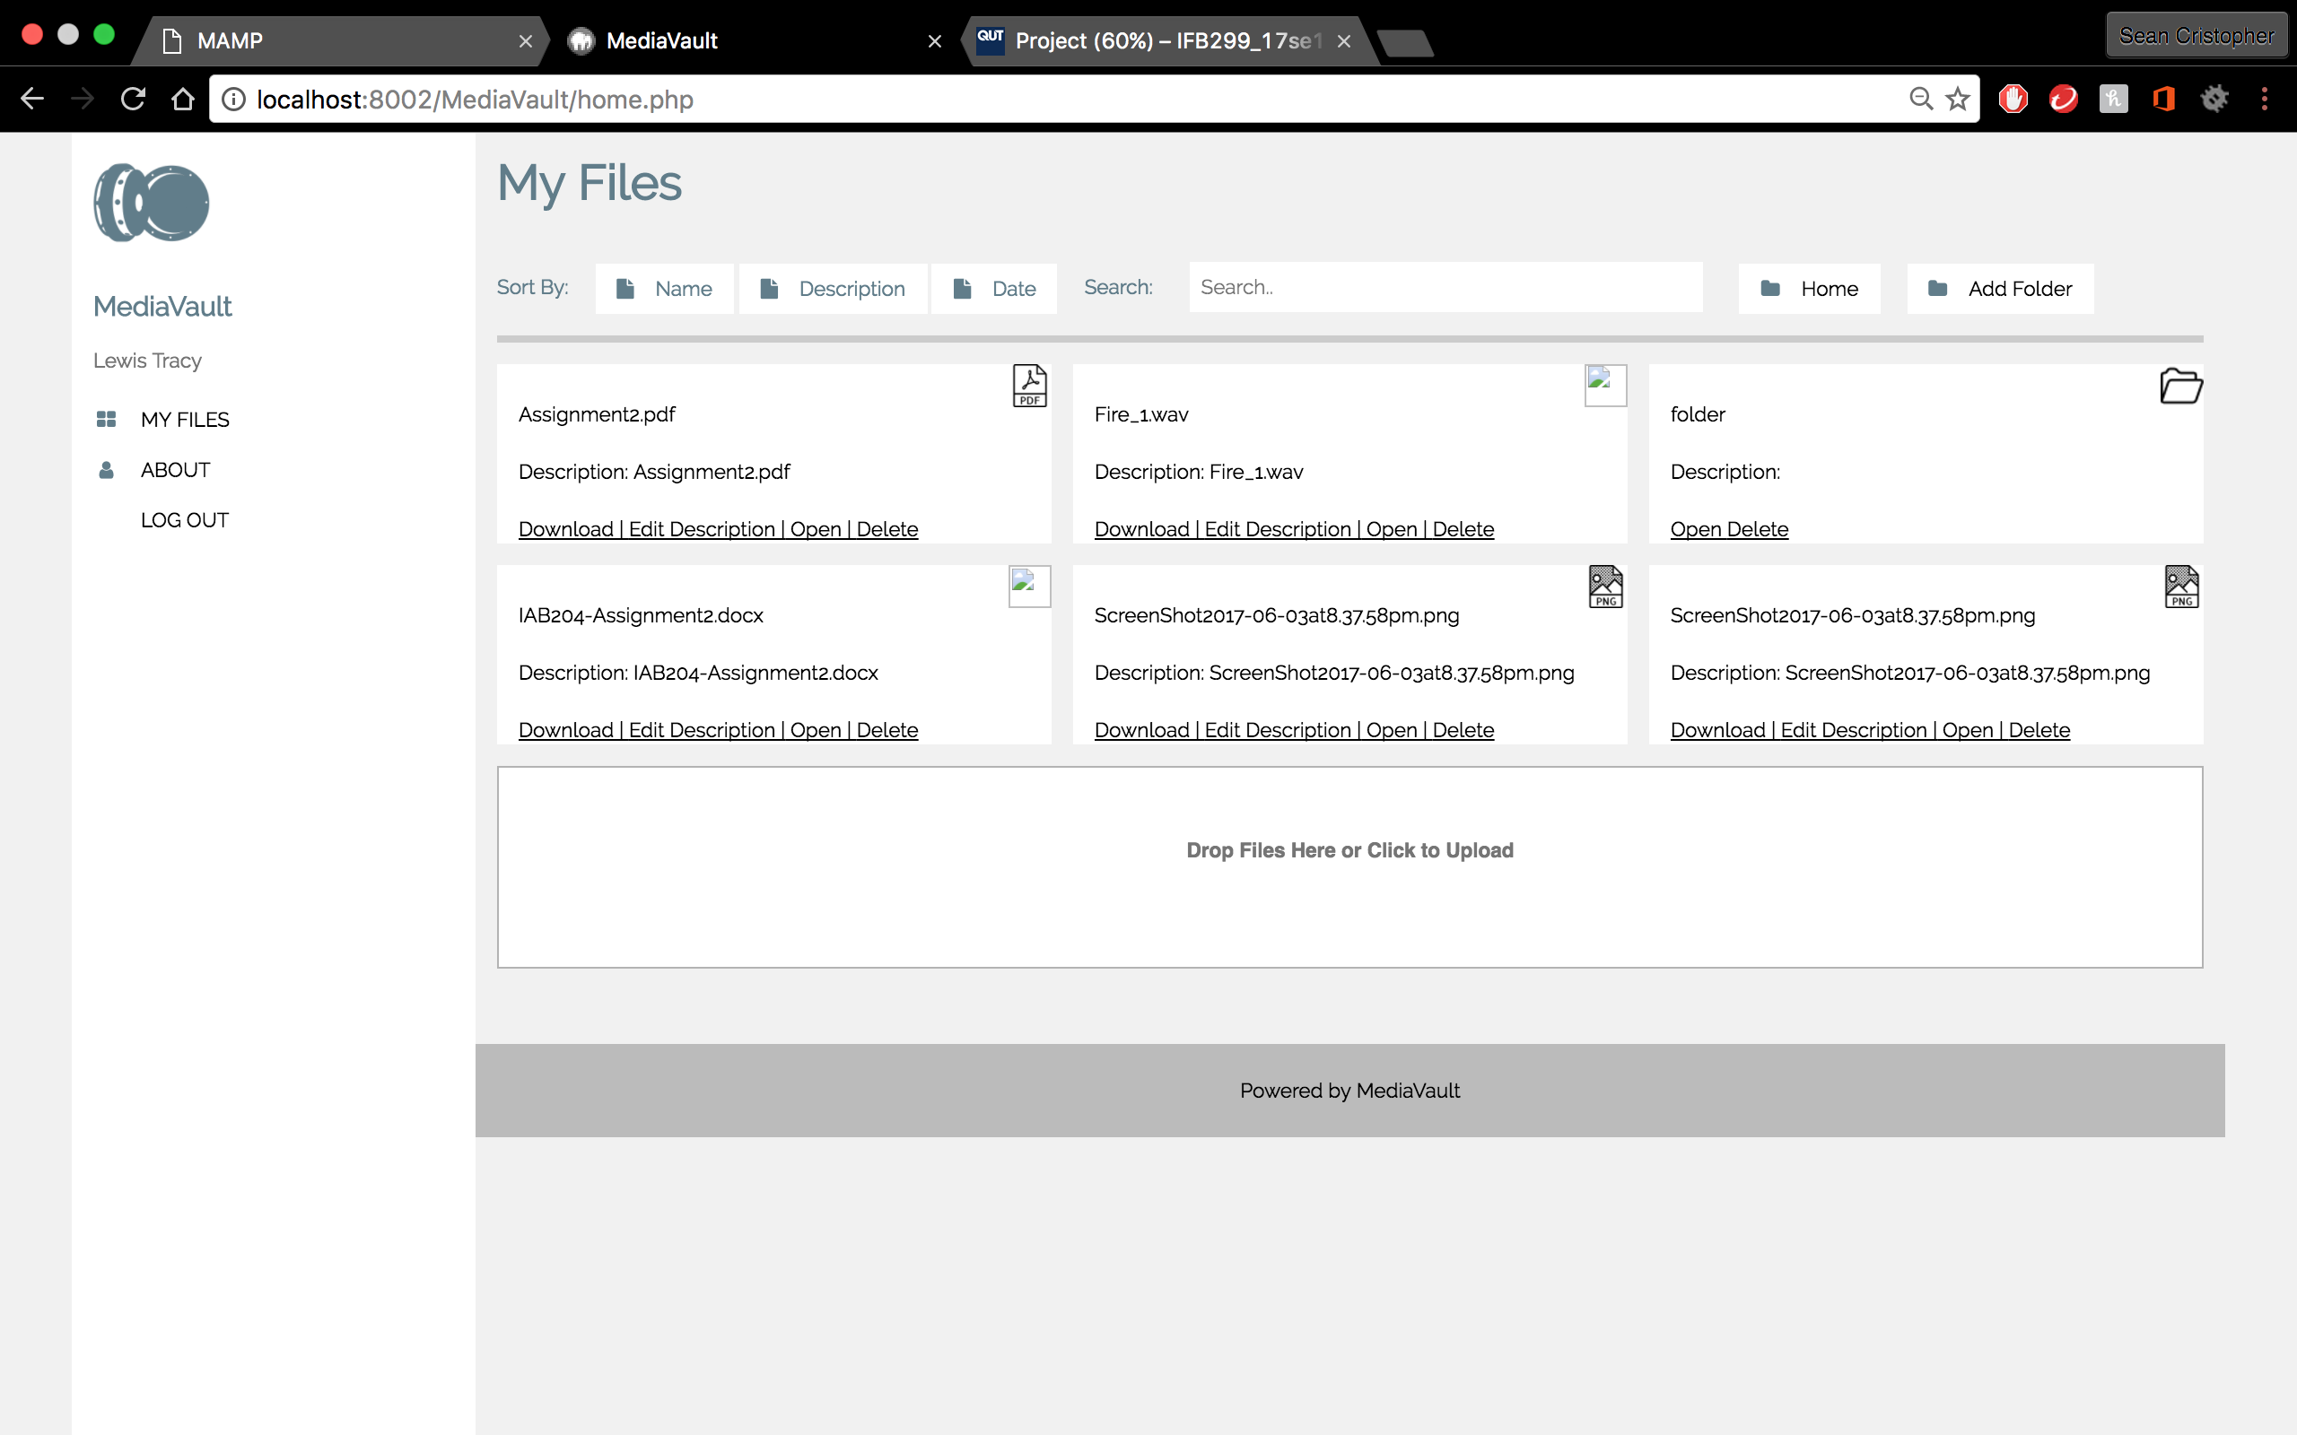

* Tests shows that sort files by name functions and sorts files/folders in alphabetical order of

Story 17C: Sort files – By Date



* Tests shows that sort by date doesn’t function

Summary: Testing shows incomplete coding of Story 17 and 17C. Story card 17B is functioning and the others are incomplete.